1. **Maven Landscape**: All of the components that make up the maven application.
2. So we will touch each of the components.
3. **POM**: 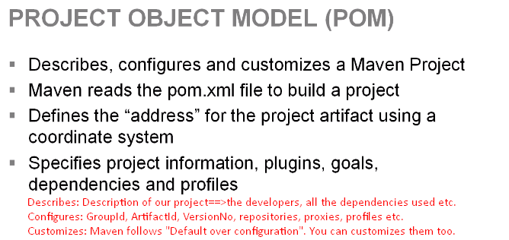
4. **Artifacts**: can be plugins, jars, archetypes.
5. 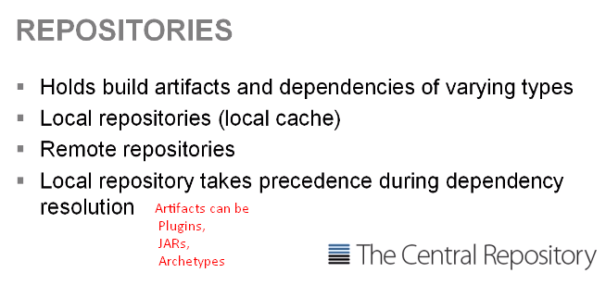
6. **Plugin**: Collection of goals.  
   **Example**: Compiler Plugin  
   It has two goals
   1. **Compile your source**
   2. **Compile your test**

**NOTE:** Imagine plugin as a class having two methods 🡺 compileSource(), compileTest()  
That is just analogy you can use from the java world to understand plugins and goals. Think of goals as actions (methods) these actions that we execute to perform our maven builds. These are the operations; you’re going to be performing against your **code base** to build a project.

1. **NOTE**: We can call the plugins and goals in different manner. You would see that there is life cycle in maven and life cycle has different phases.
2. **Each** plugin and its goals can bind to a particular phase in a life cycle.
3. **We** can also call a phase in a life cycle independently. There’re two approaches to calling a goal and performing some sort of action against our project. 